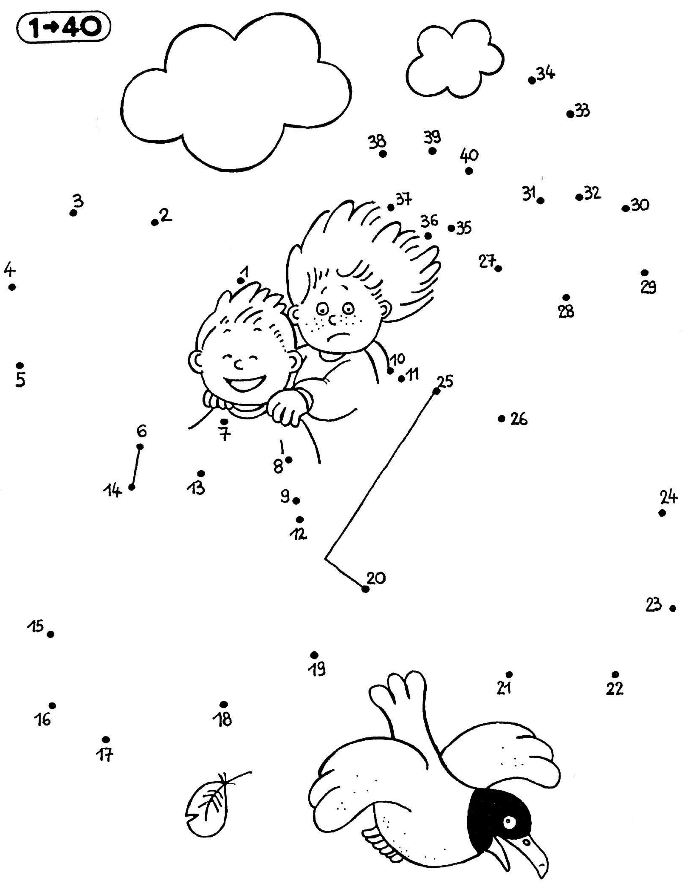

1. **Complète** ²le$ ²bande$ numérique$.

|  |  |  |  |  |  |  |  |  |  |  |  |  |  |  |  |  |
| --- | --- | --- | --- | --- | --- | --- | --- | --- | --- | --- | --- | --- | --- | --- | --- | --- |
|  |  | 13 | 14 |  | 16 | 17 | 18 | 19 |  | 21 | 22 | 23 |  |  |  |  |

|  |  |  |  |  |  |  |  |  |  |  |
| --- | --- | --- | --- | --- | --- | --- | --- | --- | --- | --- |
| 35 | 36 |  | 38 | 39 |  |  |  | 43 |  | 45 |

|  |  |  |  |  |  |  |  |  |  |  |  |  |  |  |  |
| --- | --- | --- | --- | --- | --- | --- | --- | --- | --- | --- | --- | --- | --- | --- | --- |
| 50 | 51 | 52 | 53 |  | 55 | 56 |  |  | 59 | 60 |  | 62 |  |  | 65 |

|  |  |  |  |  |  |  |  |  |  |  |  |  |  |  |  |  |
| --- | --- | --- | --- | --- | --- | --- | --- | --- | --- | --- | --- | --- | --- | --- | --- | --- |
| 23 |  |  | 26 |  | 28 | 29 | 30 |  |  |  |  | 35 |  |  |  |  |

|  |  |  |  |  |  |  |  |  |  |  |  |  |  |  |  |
| --- | --- | --- | --- | --- | --- | --- | --- | --- | --- | --- | --- | --- | --- | --- | --- |
|  | 84 |  |  | 87 | 88 | 89 | 90 |  |  | 93 | 94 |  |  | 97 | 98 |

1. **Relie** ²le$ nombre$ ²de 1 à 40.

Numération

Les bandes à compléter

Prénom :

Date :